Climate Change Major Findings

Create a write-up summarizing your major findings. This should include a heading for each "question" you asked of your data, and under each heading, a short description of what you found and any relevant plots.

Extreme weather events (count/severity/cost impact) vs global temperature?

Extreme weather events vs transit?

Energy consumption vs transit?

Extreme weather vs energy consumption?

Energy Consumption vs Global Temperature?

Write up below for questions we were able to answer:

**What is the relationship between population density and oil consumption?**

* This question was revised to the following after we gathered our data and started exploration: ***What is the relationship between population density and energy consumption?***
  + Also addresses: **Are denser countries/cities using less energy?**
* The relationship between population density and energy consumption varies per country by energy type but almost all countries seem to be increasing energy consumption at a constant rate over time. There are a few countries with high population density while the rest seem to be grouped together. The plot below depicts this:
* 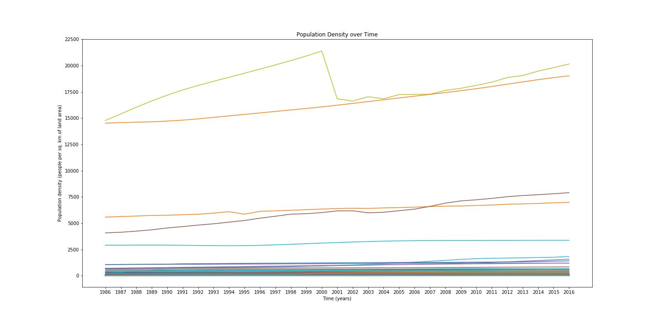Below we took Singapore and its total energy consumption from 1986-2016 as it was one of the most densely populated countries. The results show that even though population density only rose slightly, their energy consumption increased exponentially. The correlation is strong with an r-squared value of 0.97 and a p-value of 1.89e-24 meaning it is significant.  
  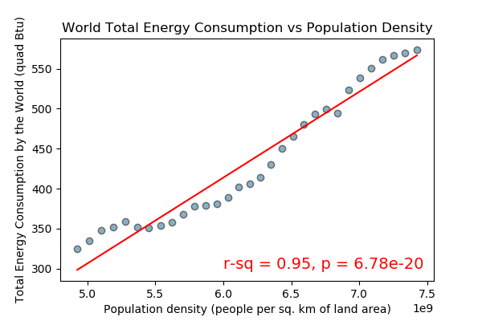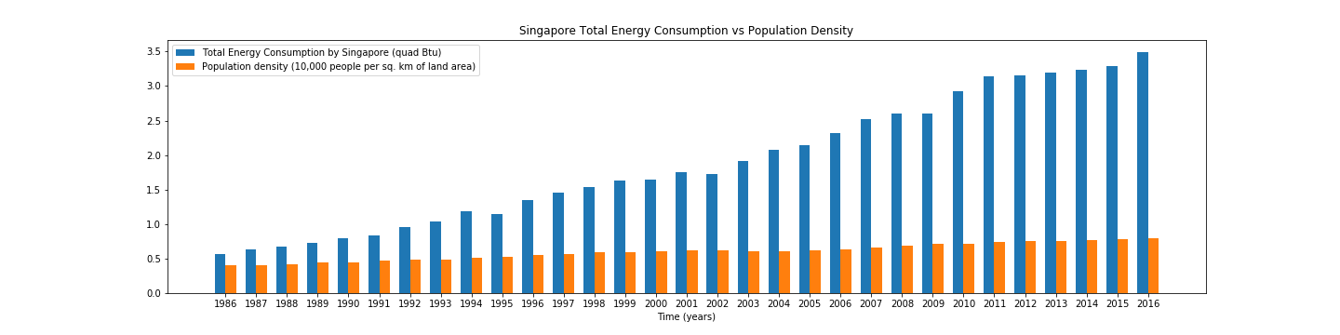
* To see an aggregate of this, we can look at the world population density (which could also just be the world population) against world total energy consumption. This shows us that population growth is linear and total energy consumption seems to be increasing as we near the end of the time range. We can see that there is a strong correlation of 0.95 which is strong and a small p-value of 6.77e-20 meaning it is significant.
* To conclude, there is a correlation between population density and the total energy consumption of the world. While some countries may have higher population densities, they may not have access to energy sources and their overall impact could be lower. The same is true for countries that have larger access to energy sources and utilize them even though they have a lower overall population density. It’s best to look at the world as a whole in this situation.

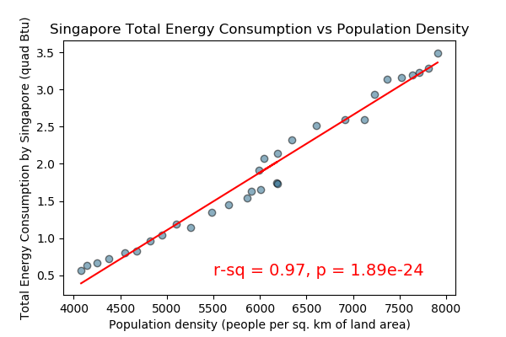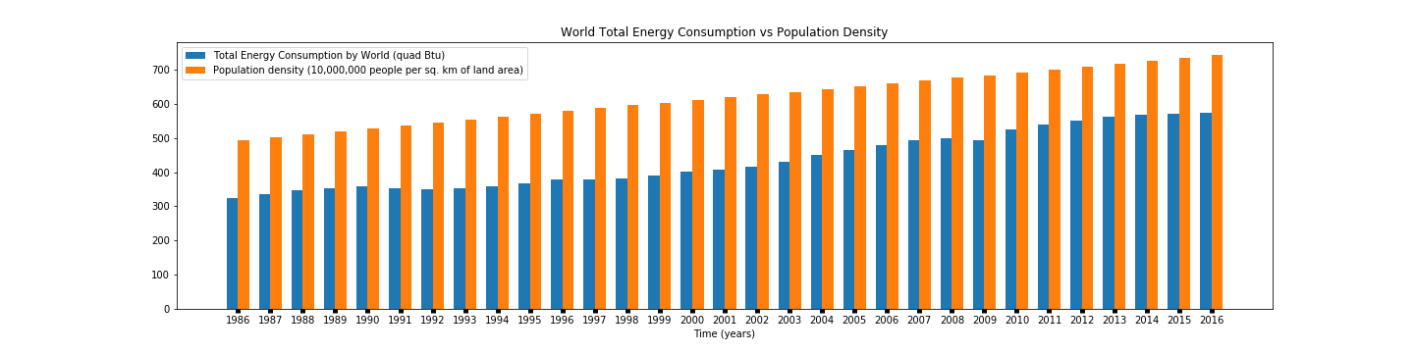

**Does an increase in oil consumption correlate with a rise in the average temperature of the world?**

* This question was revised to the following after we gathered our data and started exploration: ***Does an increase in energy consumption correlate with a rise in the average temperature of the world?***
  + Also addresses: **Fossil fuel consumption vs global temperature over time**

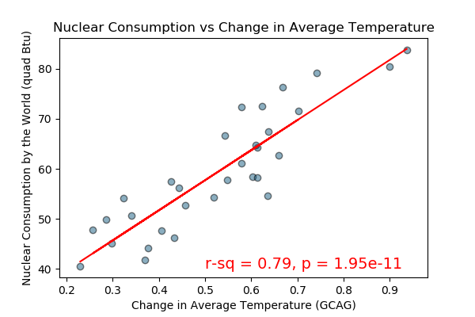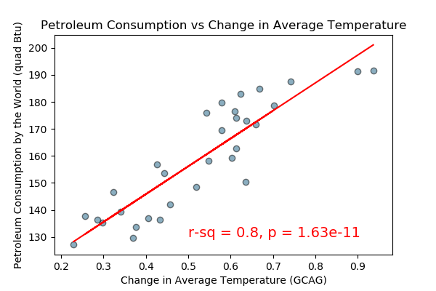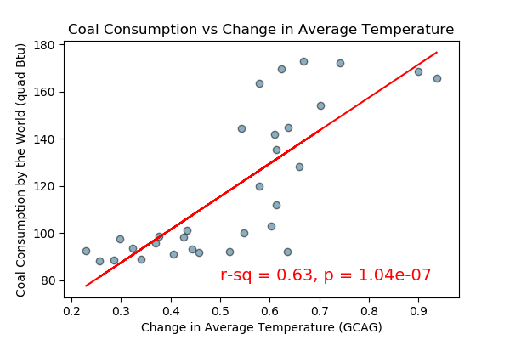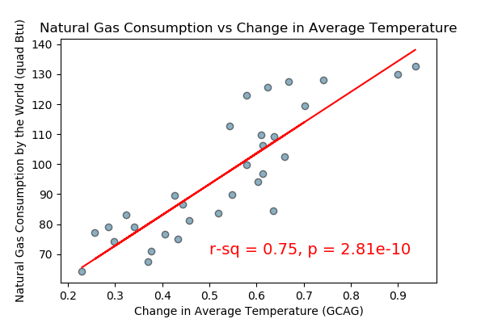

* We found that there is a correlation between different energy consumption types and change in average temperature of the world. Below are the 4 energy types we were able to find data for and how they correlate with a change in average temperature:
* As we can see there is a strong positive correlation for petroleum with an r-squared value of 0.81 and a p-value of 1.63e-11. Similar results were found for nuclear energy, natural gas (which includes some forms of renewable energy) and coal consumption. What is interesting is that coal consumption has started to see a decline since around 2013 while all other energy types continue to increase. Another point of interest is the natural gas category as it contains some renewable energy sources (it unfortunately doesn’t specify which kinds, possibly biofuels). We would need to try and find data on renewable energy sources to take a deeper dive and see if there is correlation with renewable energy consumption and change in average temperature.
* To conclude, there is definitely a correlation between energy consumption and an increase in average temperature of the world no matter which energy type is consumed. It would be interesting to do further studies on more specific types of energy such as electric, solar, and hydrogen to see what effects, if any, those types of energy have on average temperature change.

**What is the relationship between transit distance and energy consumption?**

* We found that there is a correlation between energy consumption and total transit distance. As the total distance of transit increased the amount of energy consumption also increased.
* The number shows a strong positive correlation between energy consumption and the total transit distance. The r-square is 0.92 between the two with the p-value of 1.21e-09.

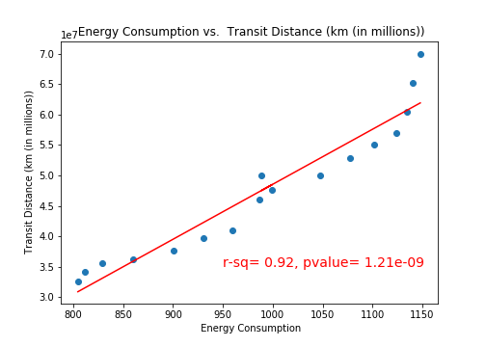

**Energy Consumption vs Global Temperature?**

* We found that there is a strong correlation between energy consumption and the temperature of the globe. The correlation value r-square is .74 and the p-value of our test was 5e-10.

